Chapter 17
Futures Markets and Risk Management

- Selling a contract is a short position. If the price rises, you lose money.
Loss = (850 – 800) x 250 = $12,500

- Futures price = 800 x (1 + .01 - .02) = 792

- The theoretical futures price = 900 x (1 + .04) = 936. At 941, the gold futures contract is overpriced. To benefit from the mispricing, we borrow 900 today and use it to buy 900 worth of gold. At the same time, we short one gold contract at a price of 941. One year from today we sell the gold at the contract price of 941 and use the proceeds to repay the loan, plus interest, of 936. Thus, the arbitrage profit is 941 – 936 = $5.

- Margin = 115,098 x .15 = 17,264.70.
Total $ loss = 115,098 – 108,000 = 7,098.
Total % loss = 7,098 / 17,264.70 = 41.11 % loss

  - The required margin is 779.40 x 250 x .10 = $19,450
  - Total gain = (790 – 779.40) x 250 = $2,650
Percentage return = 2650 / 19450 = .1362 or 13.62%
  - Total loss = (771.61 – 779.40) x 250 = -$1,947.50
Percentage loss = -1947.50 / 19450 = -.10 or 10% loss

- The ability to buy on margin is one advantage of futures. Another is the ease with which one can alter holdings of the asset. This is especially important if one is dealing in commodities, for which the futures market is far more liquid than the spot market so that transaction costs are lower in the futures market.

- Short selling results in an immediate cash inflow, whereas the short futures position does not:
Action | Initial Cash Flow | Cash Flow at Time T
Short sale | +P₀ | –P_{T}
Short futures | 0 | F₀ – P_{T}

- F₀ = S0(1 + r_{f} – d) = 800 × (1 + 0.03 – 0.02) = 808

- According to the parity relationship, the proper price for December futures is:
FDec = FJune × (l + r_{f})l/2 = $946.30 × (1.04)1/2 = $965.04
The listed futures price for December is too low relative to the June price. You should long the December contract and short the June contract.

  - .
Action | Initial Cash Flow | Cash Flow at Time T
Buy stock | –S₀ | S_{T} + D
Short futures | 0 | F₀ – S_{T}
Borrow | S₀ | –S₀(1 + r)
Total | 0 | F₀ + D – S₀(1 + r)

  - The net initial investment is zero, whereas the final cash flow is not zero. Therefore, in order to avoid arbitrage opportunities the equilibrium futures price will be the final cash flow equated to zero. Accordingly:
F0 = S0 (1 + r) – D

  - Noting that D = (d × S0), we substitute and rearrange to find that:
F0 = S0 (1 + r – d)

  - F₀ = S0(1 + r_{f}) = $150 × 1.03 = $154.50
  - F₀ = S0(1 + r_{f})³ = $150 × (1.03)³ = $163.91
  - F₀ = S0(1 + r_{f})³ = $150 × (1.05)³ = $173.64

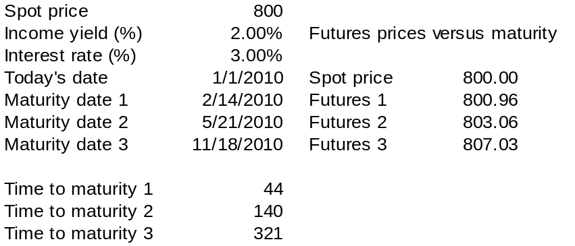

b.
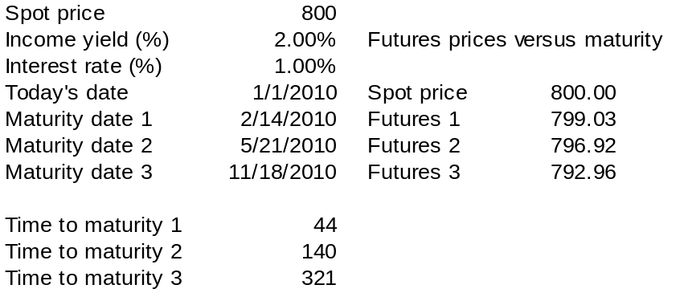

  - F₀ = S0( 1 + r_{f}) = $120 × 1.06 = $127.20
  - The stock price falls to: $120 × (1 – 0.03) = $116.40
The futures price falls to: $116.40 × 1.06 = $123.384
The investor loses: ($127.20 – $123.384) × 1,000 = $3,816.00
  - The percentage return is: (–$3,816/$12,000) = –31.8%

  - The initial futures price is:
F0 = 800 × (1 + 0.005 – 0.002)^12 = 829.28
In one month, the futures price will be:
F0 = 810 × (1 + 0.005 – 0.002)^11 = 837.13
The increase in the futures price is 7.85, so the cash flow will be:
7.85 x 250 = $1,962.50
  - The holding period return is: $1,962.50/$10,000 = 0.1963 = 19.63%

- The parity value of F₀ is: 800 × (1 + 0.03 – 0.02) = 808
The actual futures price is 833, overpriced by 25.
Action | Initial Cash Flow | Cash Flow at Time T (one year)
Buy index | –800 | S_{T} + (0.02 × 800) [CF includes 2% dividend]
Short futures | 0 | 833 – S_{T}
Borrow | 800 | –800 × 1.03

Total | 0 | 25 [A riskless cash flow]

  - The current yield on bonds (coupon interest divided by price) plays the role of the dividend yield.
  - When the yield curve is upward sloping, the current yield exceeds the short-term interest rate. Hence, net cost of carry is negative, and distant futures prices will be lower than near-term futures prices.
  - In Figure 17.1, the longer-term T-bond contracts do in fact sell at lower prices than near-term contracts.

- The actual dollar cost of funds will be determined by LIBOR. The percentage cost, however, will always be 1% above LIBOR since the company sold its 7% fixed rate loan for 6% in the SWAP. Since firm’s typically only enter into SWAPs to create a net gain, their natural floating rate is likely above LIBOR + 1%.

- The speculator who believes interest rates will fall wants to pay the floating rate and receive the fixed rate. This investor will benefit if the short-term reference rate does in fact fall, resulting in an increase in the net cash flow from the swap.

- The dollar value of the index is: $250 × 800 = $200,000
Therefore, the position requires margin of $20,000.
If the futures price decreases by 1% to 792, then the decline in the futures price is 8. The decrease in the margin account would be: 8 × $250 = $2,000
This is a percent return of: –$2,000/$20,000 = –10%
Cash in the margin account is now: $20,000 – $2,000 = $18,000

  - The initial futures price is: F0 = 800 × (1 + 0.002 – 0.001)12 = 809.65
In one month, the maturity of the contract will be only 11 months, so the futures price will be: F0 = 820 × (1 + 0.002 – 0.001)11 = 829.07
The increase in the futures price is 19.42, so the cash flow will be:
19.42 × $250 = $4,855

  - The holding period return is: $4,855/$10,000 = 0.4855 = 48.55%

- The Treasurer would like to buy the bonds today, but cannot. As a proxy for this purchase, T-bond futures contracts can be purchased. If rates do in fact fall, the Treasurer will have to buy back the bonds for the sinking fund at prices higher than the prices at which they could be purchased today. However, the gains on the futures contracts will offset this higher cost.

- She must sell: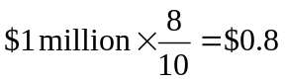million of T-bonds

- If yield changes on the bond and the contracts are each 1 basis point, then the bond value will change by:
$10,000,000 × 0.0001 × 8 = $8,000
The contract will result in a cash flow of:
$100,000 × 0.0001 × 6 = $60
Therefore, the manager should sell: 8,000/60 = 133 contracts
The manager sells the contracts because she needs the profits on the contract to offset losses as a bond issuer if interest rates increase.

  - Each contract is for $250 times the index, currently valued at 800. Therefore, each contract has the same exposure to the market as $200,000 worth of stock, and to hedge a $4 million portfolio, you need:
$4 million/$200,000 = 20 contracts

  - The parity value of the futures price = 800 × (1 + 0.02 – 0.01) = 808
Action | Initial Cash Flow | Cash Flow at Time T
Short 20 futures contracts | 0 | 20 × $250 × (808 – S_{T})
Buy 5,000 “shares” of index | –$4 million | ($4 million × 0.01) + (5,000 × S_{T})
(each share equals $800)
Total | 0 | $4.08 million [which is riskless]
Thus the riskless return on the hedged strategy equals the T-bill rate of 2%.

  - Now, your stock swings only 0.6 as much as the market index. Hence, you need 0.6 as many contracts as in part (a): 0.60 × 20 = 12 contracts
In this case, however, the hedged position will not be riskless since you are exposed to the stock’s unsystematic risk. The beta of the hedged position is zero since all the systematic risk is hedged.

- The firm should enter a swap in which it pays a 7% fixed rate and receives LIBOR on $10 million of notional principal. Its total payments will be as follows:
Interest payments on bond: (LIBOR + 0.01) × $10 million par value
Net cash flow from swap: (0.07 – LIBOR) × $10 million notional principal
TOTAL 0.08 × $10 million
The interest rate on the synthetic fixed-rate loan is 8%.

  - From parity: F0 = [400 × (1 + 0.03)] – 5 = 407
Actual F0 is 406, so the futures price is $1 below its "proper" or parity value.

  - Buy the relatively cheap futures and sell the relatively expensive stock.
Action | Initial Cash Flow | Cash Flow at Time T
Sell stock | +400 | –(S_{T} + 5)
Buy futures | 0 | S_{T} – 406
Lend $400 | –400 | +412
Total | 0 | 1

  - If you do not receive interest on the proceeds of the short sales, then the $400 you receive will not be invested, but rather will simply be returned to you. The proceeds from the strategy in part (b) is now negative: an arbitrage opportunity no longer exists.
Action | Initial Cash Flow | Cash Flow at Time T
Sell stock | +400 | –(S_{T} + 5)
Buy futures | 0 | S_{T} – 406
Place $400 in margin account | –400 | +400
Total | 0 | –11

  - If we call the original futures price F0, then the proceeds from the long-futures, short-stock strategy are:
Action | Initial Cash Flow | Cash Flow at Time T
Sell stock | +400 | –(S_{T} + 5)
Buy futures | 0 | S_{T} – F₀
Place $400 in margin account | –400 | +400
Total | 0 | 395 – F₀
Therefore, F0 can be as low as 395 without giving rise to an arbitrage opportunity. On the other hand, if F0 is higher than the parity value (407) an arbitrage opportunity (buy stocks, sell futures) will open up. There is no short-selling cost in this case. Therefore, the no-arbitrage region is:
395 ≤ F0 ≤ 407

CFA 1
Answer: a

CFA 2
Answer: d

CFA 3
Total losses may amount to $1,500 before a margin call is received. Each contract calls for delivery of 5,000 ounces. Before a margin call is received, the price per ounce can increase by: $1,500/5,000 = $0.30. The futures price at this point would be: $14 + $0.30 = $14.30

CFA 4
  - Take a short position in T-bond futures, to offset interest rate risk. If rates increase, the loss on the bond will be offset by gains on the futures.
  - Again, a short position in T-bond futures will offset the bond price risk.
  - You wish to protect your cash outlay when the bond is purchased. If bond prices increase you will need extra cash to purchase the bond with the anticipated contribution. Thus, you want a long futures position that will generate a profit if prices increase.

CFA 5
The important distinction between a futures contract and an options contract is that the futures contract is an obligation. When an investor purchases or sells a futures contract, the investor has an obligation to accept or deliver, respectively, the underlying commodity on the delivery date. In contrast, the buyer of an option contract is not obligated to accept or deliver the underlying commodity but instead has the right, or choice, to accept or deliver the underlying commodity anytime during the life of the contract.

Futures and options modify a portfolio’s risk in different ways. Buying or selling a futures contract affects a portfolio’s upside risk and downside risk by a similar magnitude. This is commonly referred to as symmetrical impact. On the other hand, the addition of a call or put option to a portfolio does not affect a portfolio’s upside risk and downside risk to a similar magnitude. Unlike futures contracts, the impact of options on the risk profile of a portfolio is asymmetrical.

CFA 6
  - The strategy that would take advantage of the arbitrage opportunity is a Reverse Cash and Carry. A Reverse Cash and Carry arbitrage opportunity results when the following relationship does not hold true:
F_{0,t} ≥ S₀ (1+ C)
If the futures price is less than the spot price plus the cost of carrying the goods to the futures delivery date, an arbitrage in the form of a Reverse Cash and Carry exists. A trader would be able to sell the asset short, use the proceeds to lend at the prevailing interest rate, and buy the asset for future delivery. At the future delivery, the trader then collects the proceeds from the loan with interest, accepts delivery of the asset, and covers the short position of the commodity.

Opening Transaction Now
Sell the spot commodity short | +$120.00
Buy the commodity futures expiring in 1 year | 0.00

Contract to lend $120 at 8% for 1 year | -$120.00
Total cash flow | $0.00

Closing Transaction One Year from Now
Accept delivery on expiring futures | -$125.00
Cover short commodity position | 0.00
Collect on loan of $120 | +$129.60
Total arbitrage profit | $4.60

CFA 7
  - In an interest rate swap, one firm exchanges (or "swaps") a fixed payment for another payment that is tied to the level of interest rates. One party in the swap agreement pays a fixed interest rate on the notional principal of the swap. The other party pays the floating interest rate (typically LIBOR) on the same notional principal. For example, in a swap with a fixed rate of 8% and notional principal of $100 million, the net cash payment for the firm that pays the fixed rate and receives the floating rate would be: (LIBOR – 0.08) × $100 million
Therefore, if LIBOR exceeds 8%, then this firm receives a payment; if LIBOR is less than 8%, then the firm makes a payment.

  - There are several applications of interest rate swaps. For example, suppose that a portfolio manager is holding a portfolio of long-term bonds, but is worried that interest rates might increase, causing a capital loss on the portfolio. This portfolio manager can enter a swap to pay a fixed rate and receive a floating rate, thereby converting the holdings into a synthetic floating rate portfolio. Or, a pension fund manager might identify some money market securities that are paying excellent yields compared to other comparable-risk short-term securities. However, the fund manager might believe that such short-term assets are inappropriate for the portfolio. The fund can hold these securities and enter a swap in which the fund receives a fixed rate and pays a floating rate. The fund thus captures the benefit of the advantageous relative yields on these securities, but still establishes a portfolio with interest-rate risk characteristics more like those of long-term bonds.

CFA 8
  - Delsing should sell stock index futures contracts and buy bond futures contracts. This strategy is justified because buying the bond futures and selling the stock index futures provides the same exposure as buying the bonds and selling the stocks. This strategy assumes high correlations between the movements of the bond futures and bond portfolio and also between the stock index futures and the stock portfolio.

  - Compute the number of contracts in each case as follows:
i. 5 × $200,000,000 × 0.0001 = $100,000
$100,000/97.85 = 1,022 contracts
ii. $200,000,000/($1,378 × 250) = 581 contracts

CFA 9
  - Short the contract. As rates rise, prices will fall. Selling the futures contract will benefit from falling prices.
  - In 6 months the bond will accrue $25 of interest, which, when subtracted from the price of 978.40, leaves a bond value of 953.40. This implies a YTM of 5.30%. Assuming the underlying bond on the contract also has a 5% coupon and 10 years to maturity, the YTM on the contract is 4.68%. A drop in the price of the bond implies an increase in the YTM of 0.30%. If the YTM on the contract increases to 4.98% the contract price in 6 months will be 976.72.
  - The contract drops in price by 47.98, while the bond drops in price 46.60. Both exclude accrued interest. Thus, the combined portfolio will increase in value by 1.38, since the investor has a short position in the contract.

